

**Project report on Diagnostic imaging**

**2021-2022**

Dipannita singha, 24

Ananya hajra, 3

Manisha ganguly, 35

Tinku garai, 73

Isma aktari, 29

Devlina paria, 21

COURSE : BSC (HONS) NURSING 1ST YEAR

SUBJECT: COMPUTER SCIENCE

GUIDED BY = Dr Biswaranjan Mishra

CONTENTS

1. INTRODUCTION

2. TYPES OF DIAGNOSTIC IMAGING

3. MRI- (a) Definition

(b) Purpose

(c) Procedure

(d)Risk

4.CT Scan-(a) Definition

(b) Purpose

(c) Procedure

(d)Risk

5 .X-RAY- (a) Definition

(b) Purpose

(c) Procedure

(d)Risk

6. ULTRASOUND-(a) Definition

(b) Purpose

(c) Procedure

(d)Risk

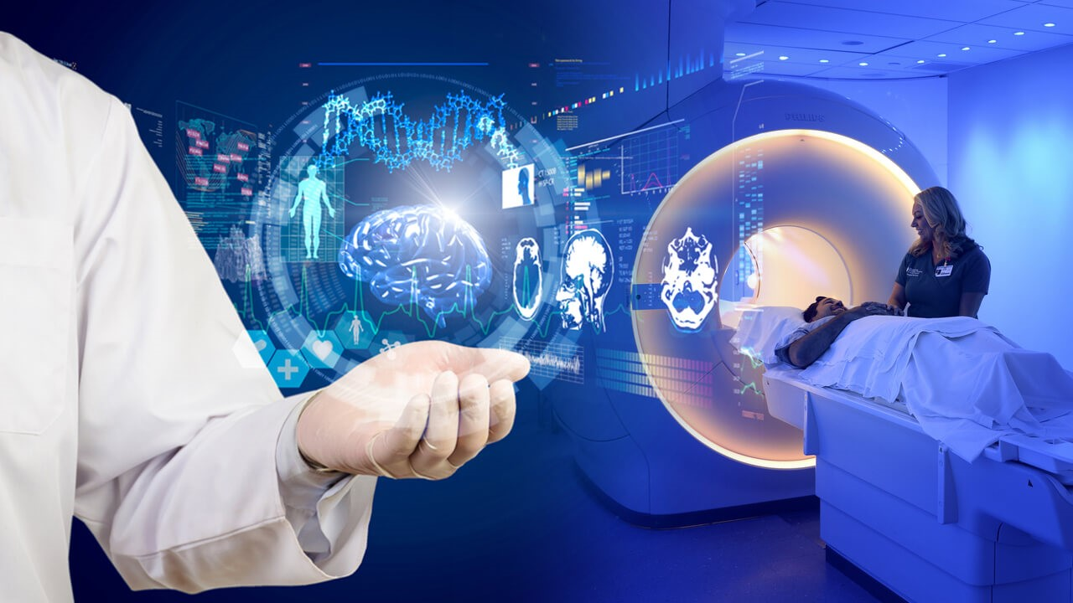

INTRODUCTION

Diagnostic imaging, also called medical imaging, the use of electromagnetic radiation and certain other technologies to produce images of internal structures of the body for the purpose of accurate diagnosis. Diagnostic imaging is roughly equivalent to radiology, the branch of medicine that uses radiation to diagnose and treat diseases. However, other technologies—including ultrasound, which employs sound waves to visualize tissues, and endoscopy and similar methods in which a flexible optical instrument is equipped with a camera for imaging—may also be used.



**MAGNETIC RESONANCE IMAGING**

**Definition**

Magnetic Resonance Imaging (MRI) is a non-invasive imaging technology that produces three dimensional detailed anatomical images. It is often used for disease detection and treatment monitoring. It is based on sophisticated technology that excites and detects the change in the direction of the rotational axis of protons found in the water that makes up living tissue.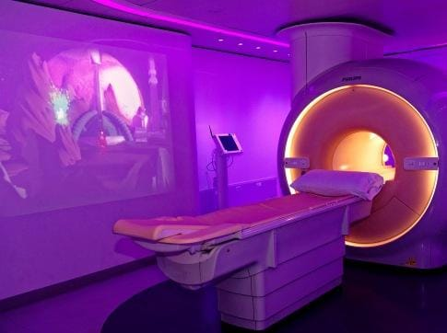

**How does it works**

MRIs employ powerful magnets which produce a strong magnetic field that forces protons in the body to align with that field. When a radiofrequency current is then pulsed through the patient, the protons are stimulated, and spin out of equilibrium, straining against the pull of the magnetic field. When the radiofrequency field is turned off, the MRI sensors are able to detect the energy released as the protons realign with the magnetic field. The time it takes for the protons to realign with the magnetic field, as well as the amount of energy released, changes depending on the environment and the chemical nature of the molecules. Physicians are able to tell the difference between various types of tissues based on these magnetic properties.

To obtain an MRI image, a patient is placed inside a large magnet and must remain very still during the imaging process in order not to blur the image. Contrast agents (often containing the element Gadolinium) may be given to a patient intravenously before or during the MRI to increase the speed at which protons realign with the magnetic field. The faster the protons realign, the brighter the image.

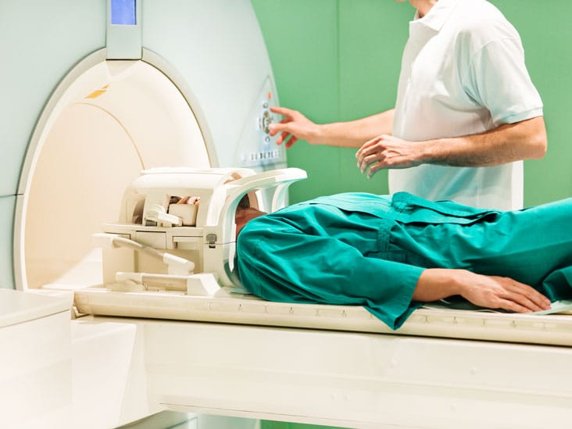

**Uses**

MRI scanners are particularly well suited to image the non-bony parts or soft tissues of the body. They differ from computed tomography (CT), in that they do not use the damaging ionizing radiation of x-rays. The brain, spinal cord and nerves, as well as muscles, ligaments, and tendons are seen much more clearly with MRI than with regular x-rays and CT; for this reason MRI is often used to image knee and shoulder injuries.

In the brain, MRI can differentiate between white matter and grey matter and can also be used to diagnose aneurysms and tumours. Because MRI does not use x-rays or other radiation, it is the imaging modality of choice when frequent imaging is required for diagnosis or therapy, especially in the brain. However, MRI is more expensive than x-ray imaging or CT scanning.

One kind of specialized MRI is functional Magnetic Resonance Imaging (fMRI.) This is used to observe brain structures and determine which areas of the brain “activate” (consume more oxygen) during various cognitive tasks. It is used to advance the understanding of brain organization and offers a potential new standard for assessing neurological status and neurosurgical risk.

The MRI exam poses almost no risk to the average patient when appropriate safety guidelines are followed.

If sedation is used, there is a risk of using too much. However, your vital signs will be monitored to minimize this risk.

The strong magnetic field is not harmful to you. However, it may cause implanted medical devices to malfunction or distort the images.

Nephrogenic systemic fibrosis is a recognized complication related to injection of gadolinium contrast. It is exceptionally rare with the use of newer gadolinium contrast agents. It usually occurs in patients with serious kidney disease. Your doctor will carefully assess your kidney function before considering a contrast injection.

There is a very slight risk of an allergic reaction if your exam uses contrast material. Such reactions are usually mild and controlled by medication. If you have an allergic reaction, a doctor will be available for immediate assistance.

Although there are no known health effects, evidence has shown that very small amounts of gadolinium can remain in the body, particularly the brain, after multiple MRI exams. This is most likely to occur in patients receiving multiple MRI exams over their lifetime for monitoring chronic or high-risk health conditions. The contrast agent is mostly eliminated from the body through the kidneys. If you are a patient in this category, consult with your doctor about the possibility of gadolinium retention, as this effect varies from patient to patient.

CT SCAN

**DEFINATION**

A CT scan or computed tomography scan (formerly known as computed axial tomography or CAT scan) is a medical imaging technique used in radiology (x-ray) to obtain detailed internal images of the body noninvasively for diagnostic purposes. The personnel that perform CT scans are called radiographers or radiology technologists.

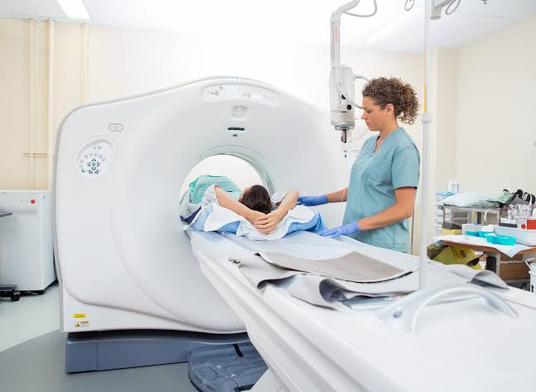

**How Do CT Scans Work?**

They use a narrow X-ray beam that circles around one part of your body. This provides a series of images from many different angles. A computer uses this information to create a cross-sectional picture. Like one piece in a loaf of bread, this two-dimensional (2D) scan shows a “slice” of the inside of your body.

This process is repeated to produce a number of slices. The computer stacks these scans one on top of the other to create a detailed image of your organs, bones, or blood vessels. For example, a surgeon may use this type of scan to look at all sides of a tumour to prepare for an operation.

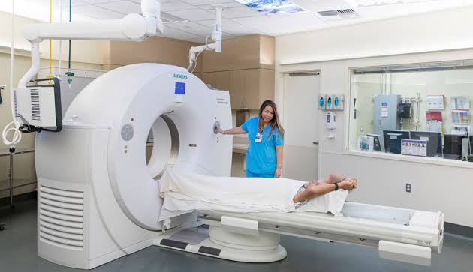

**Uses of CT scan**

CT scans can detect bone and joint problems, like complex bone fractures and tumours.

If you have a condition like cancer, heart disease, emphysema, or liver masses, CT scans can spot it or help doctors see any changes.

They show internal injuries and bleeding, such as those caused by a car accident.

They can help locate a tumor, blood clot, excess fluid, or infection.

Doctors use them to guide treatment plans and procedures, such as biopsies, surgeries, and radiation therapy.

Doctors can compare CT scans to find out if certain treatments are working. For example, scans of a tumour over time can show whether it’s responding to chemotherapy or radiation.

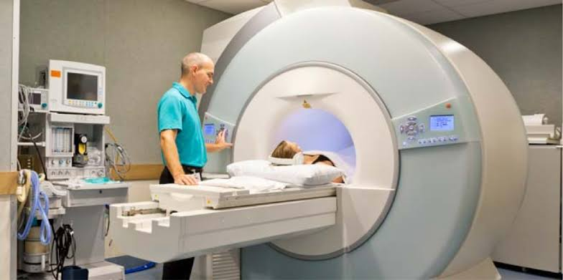

**Risks**

CT scans use X-rays, which produce ionizing radiation. Research shows that this kind of radiation may damage your DNA and lead to cancer. But the risk is still very small -- your chances of developing a fatal cancer because of a CT scan are about 1 in 2,000.

Ionizing radiation may be more harmful in children. That’s because they’re still growing. They also have more years to get exposed to radiation. Before the procedure, you may want to ask the doctor or technician if the CT machine’s settings have been adjusted for a child.

**X-RAY**

**Defination**

An electromagnetic wave of high energy and very short wavelength, which is able to pass through many materials opaque to light.

A photographic or digital image of the internal composition of something, especially a part of the body, produced by X-rays being passed through it and being absorbed to different degrees by different materials.

X-rays use invisible electromagnetic energy beams to produce images of internal tissues, bones, and organs on film or digital media. Standard X-rays are performed for many reasons, including diagnosing tumours or bone injuries.

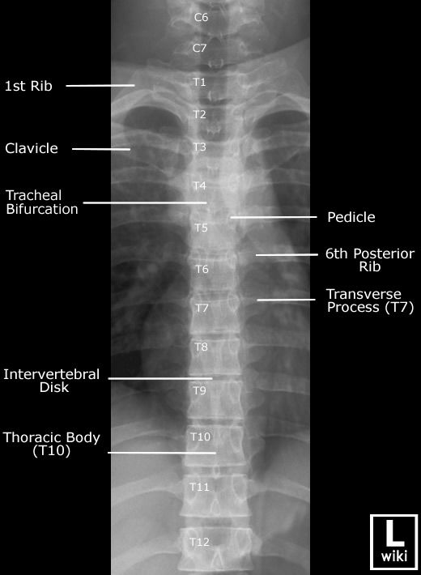

**Procedures**

In the procedure, a machine sends X-ray beams through your body. The resulting images are recorded either on film or by a computer. X-ray images show the body in shades of black and white, because different tissues absorb different amounts of radiation.

**Use**

The most familiar use of x-rays is checking for fractures (broken bones), but x-rays are also used in other ways. For example, chest x-rays can spot pneumonia.

Mammograms use x-rays to look for breast cancer. When you have an x-ray, you may wear a lead apron to protect certain parts of your body.

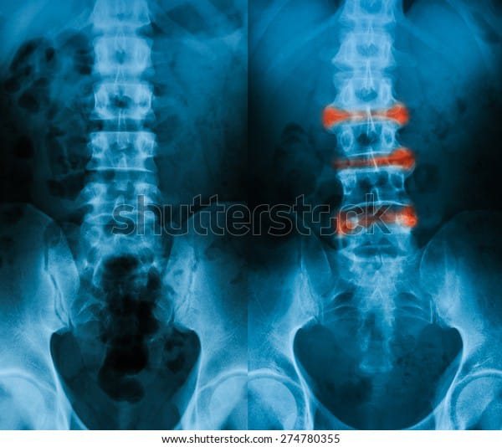

**Risk:**

A small increase in the possibility that a person exposed to X-rays will develop cancer later in life tissues effects such as cataracts, skin reddening, and hair loss, which occur at relatively high levels of radiation exposure and are rare for many types of imaging exams

**ULTRASOUND**

**DEFINATION**

Ultrasound, also called sonography , uses sound waves to develop ultrasound images of what's going on inside the body. An instrument called a transducer emits high-frequency sound, inaudible to human ears, and then records the echoes as the sound waves bounce back to determine the size, shape, and consistency of soft tissues and organs.

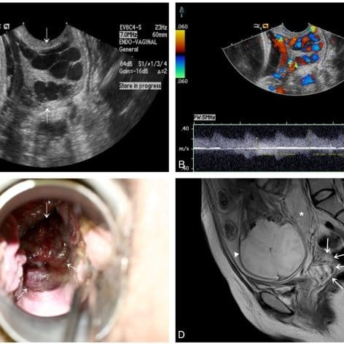

**PURPOSE**

A sonogram captures a live image of what's going on inside the body. Sonography is useful for evaluating the size, shape, and density of tissues to help diagnose certain medical conditions. Traditionally, ultrasound imaging is great for looking into the abdomen without having to cut it open. Abdominal ultrasound is often used to diagnose:

Gallbladder disease or gallstones

Kidney stones or kidney disease

Liver disease

Appendicitis

Ovarian cysts

Ectopic pregnancy

Uterine growths or fibroids and other conditions

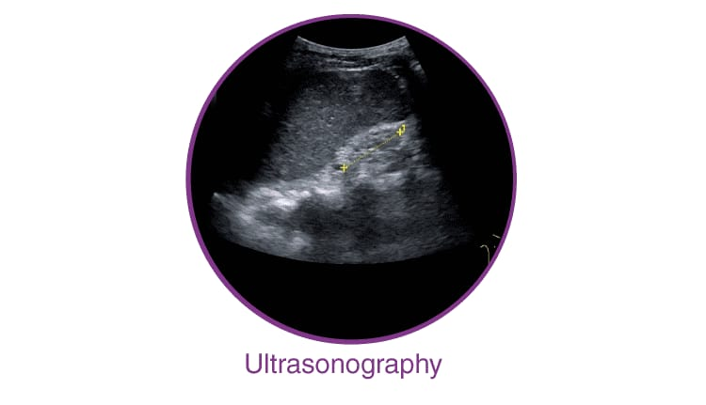

**PROCEDURE**

During an ultrasound, a healthcare provider passes a device called a transducer or probe over an area of your body or inside a body opening. The provider applies a thin layer of gel to your skin so that the ultrasound waves are transmitted from the transducer through the gel and into your body.

The probe converts electrical current into high-frequency sound waves and sends the waves into your body’s tissue. You can’t hear the sound waves.

Sound waves bounce off structures inside your body and back to the probe, which converts the waves into electrical signals. A computer then converts the pattern of electrical signals into real-time images or videos, which are displayed on a computer screen nearby

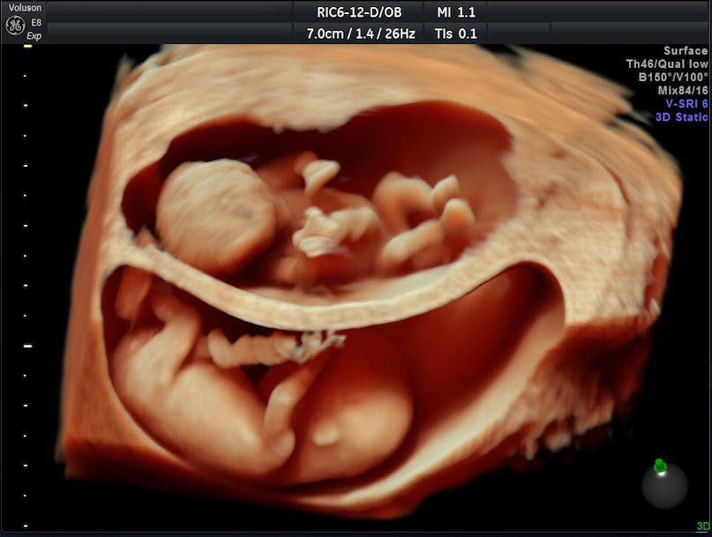

**RISK**

Diagnostic ultrasound is a safe procedure that uses low-power sound waves. There are no known risks.

Ultrasound is a valuable tool, but it has limitations. Sound waves don't travel well through air or bone, so ultrasound isn't effective at imaging body parts that have gas in them or are hidden by bone, such as the lungs or head. Ultrasound may also be unable to see objects that are located very deep in the human body. To view these areas, your health care provider may order other imaging tests, such as CT or MRI scans or X-rays.

CONCLUSION

Diagnostic imaging lets doctors look inside your body for clues about a medical condition. A variety of machines and techniques can create pictures of the structures and activities inside your body. The type of imaging your doctor uses depends on your symptoms and the part of your body being examined.

Many imaging tests are painless and easy. Some require you to stay still for a long time inside a machine. This can be uncomfortable. Certain tests involve exposure to a small amount of radiation.



**THANK YOU**